Assignment 9 : Exercise 16: Clustering

Ragunath Gunasekaran

2020-11-01

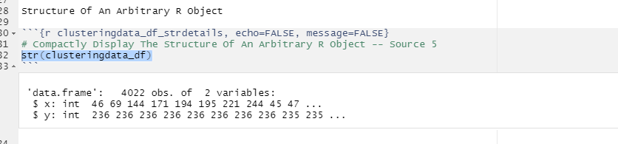

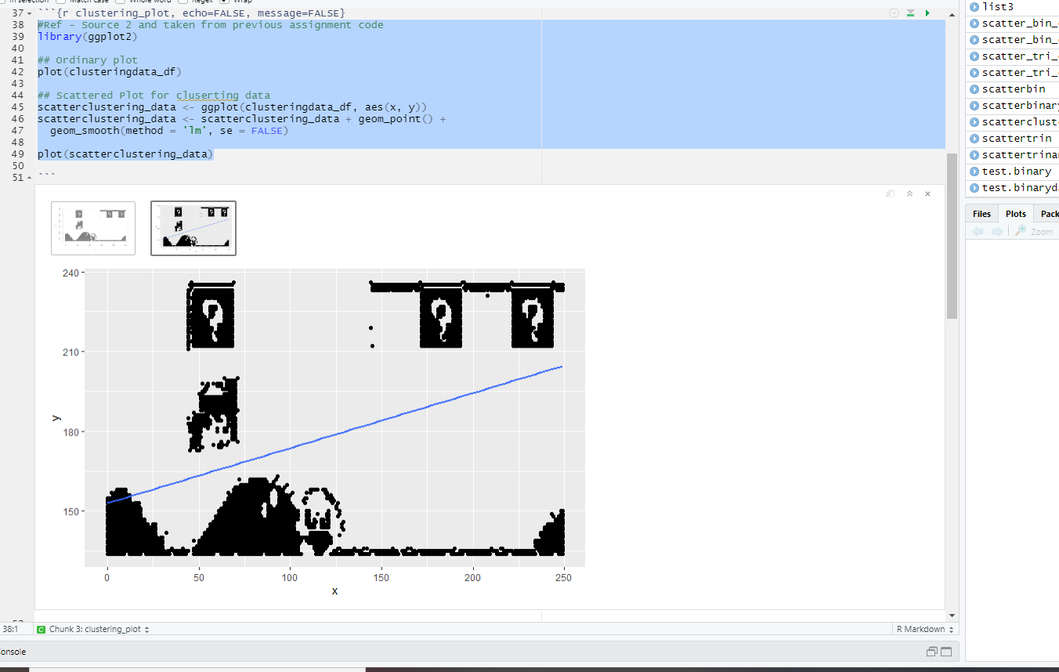

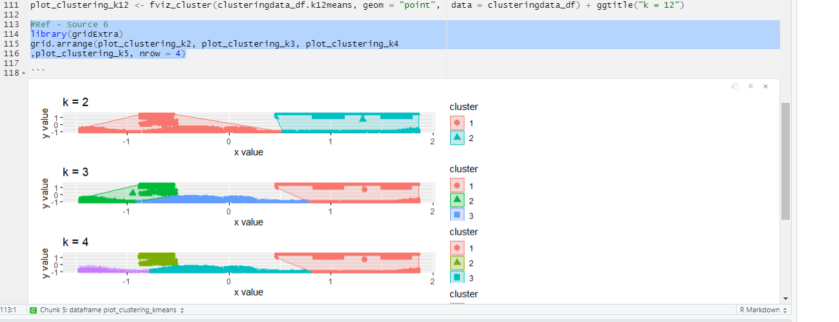

# References

1. Sejal Jaiswal. (2018). K-Means Clustering in R Tutorial
2. <https://rpubs.com/dnchari/ggplot2>
3. <https://towardsdatascience.com/clustering-with-k-means-1e07a8bfb7ca>
4. <https://rpubs.com/dnchari/kmeans>
5. <https://www.youtube.com/watch?v=3GorGZgTTEk>
6. <https://rpubs.com/abdul_yunus/Kmeans_Clustering>
7. <https://cran.r-project.org/web/packages/factoextra/factoextra.pdf>